 |  | 67D SERIES |  |  | WIDE INPUT VOLTAGE RANGE
 |  |  |  |  | 15 WATTS DC-DC CONVERTER
 | FEATURES |  |  |  |  | 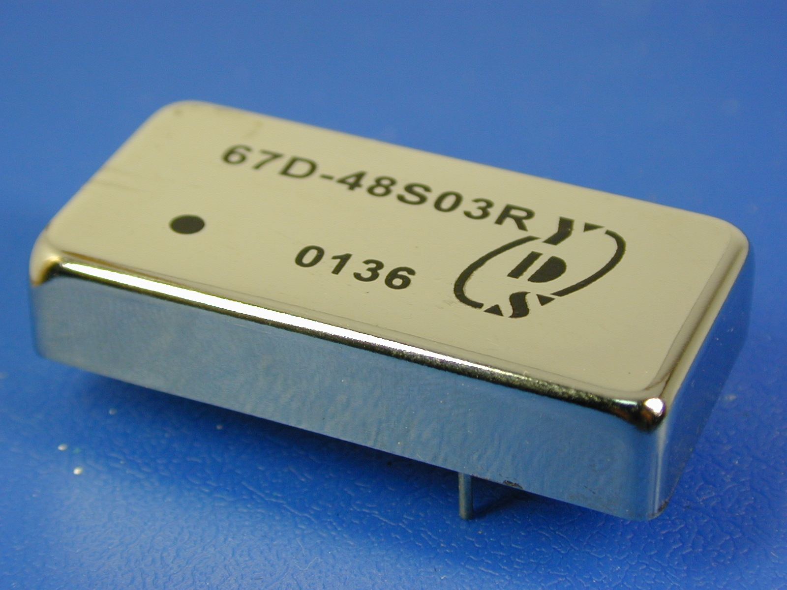
• 2:1 WIDE INPUT VOLTAGES:9-18V,18-36V,36-72V
• 15 WATTS (2x1x0.4inches) PACKAGE
• EFFICIENCY TO 80%
• P1 INPUT FILTER
 | GENERAL SPECIFICATIONS |  |  |  |  | ELECTRICAL SPECIFICATIONS
 | • SWITCHING FREQUENCY |  |  | : 300KHz TYP. |  | • INPUT VOLTAGE RANGE |  |  | :12V nominal …9-18V
 | • OUTPUT RIPPPLE & NOISE |  |  | : 100mVp-p(20MHz B.W.) |  |  |  |  | :24V nominal …18-36V
 | • ISOLATION VOLTAGE |  |  | : 1500VDC |  |  |  |  | :48V nominal …36-72V
 | • ISOLATION RESISTANCE |  |  | :10⁹ ohms |  | • OUTPUT VOLTAGE ACCURACY |  |  | :±2%
 | • STORAGE TEMPERATURE RANGE |  |  | :-40℃ TO 100℃ |  | • LINE REGULATION |  |  | :±1.0%(HL-LL)
 | • OPERATING TEMPERATURE RANGE |  |  | :-25℃ TO +71℃ |  | • LOAD REGULATION(SINGLE) |  |  | :±1.0%(100% to 10%)
 | • SHORT CIRCUIT PROTECTION |  |  | : CONTINUOUS |  | • LOAD REGULATION(DUAL) |  |  | :±2%(100% to 10%)
 | • CASE MATERIAL |  |  | : BLACK COATED COPPER WITH |  | • EFFICIENCY |  |  | :see table
 |  |  |  | NON-CONDUCTIVE BASE |  | • EMI/RFI |  |  | :six-sided continuous shield
 | PART N0. |  | INPUT RANGE |  | OUTPUT  VOLTAGE |  | OUTPUT  CURRENT |  |  | EFFICIENCY  (%)
 | 67D-12S05R |  | 9-18VDC |  | 5VDC |  | 3000mA |  |  | 81
 | 67D-12S12R |  | 9-18VDC |  | 12VDC |  | 1250mA |  |  | 83
 | 67D-12S15R |  | 9-18VDC |  | 15VDC |  | 1000mA |  |  | 83
 | 67D-12D12R |  | 9-18VDC |  | ±12VDC |  | ±625mA |  |  | 83
 | 67D-12D15R |  | 9-18VDC |  | ±15VDC |  | ±500mA |  |  | 83
 | 67D-24S05R |  | 18-36VDC |  | 5VDC |  | 3000mA |  |  | 82
 | 67D-24S12R |  | 18-36VDC |  | 12VDC |  | 1250mA |  |  | 84
 | 67D-24S15R |  | 18-36VDC |  | 15VDC |  | 1000mA |  |  | 84
 | 67D-24D12R |  | 18-36VDC |  | ±12VDC |  | ±625mA |  |  | 84
 | 67D-24D15R |  | 18-36VDC |  | ±15VDC |  | ±500mA |  |  | 84
 | 67D-48S05R |  | 36-72VDC |  | 5VDC |  | 3000mA |  |  | 83
 | 67D-48S12R |  | 36-72VDC |  | 12VDC |  | 1250mA |  |  | 84
 | 67D-48S15R |  | 36-72VDC |  | 15VDC |  | 1000mA |  |  | 84
 | 67D-48D12R |  | 36-72VDC |  | ±12VDC |  | ±625mA |  |  | 84
 | 67D-48D15R |  | 36-72VDC |  | ±15VDC |  | ±500mA |  |  | 84
 | MARKINGS AND DIMENSIONS |  |  |  |  |  | PIN CONNECTION
 | 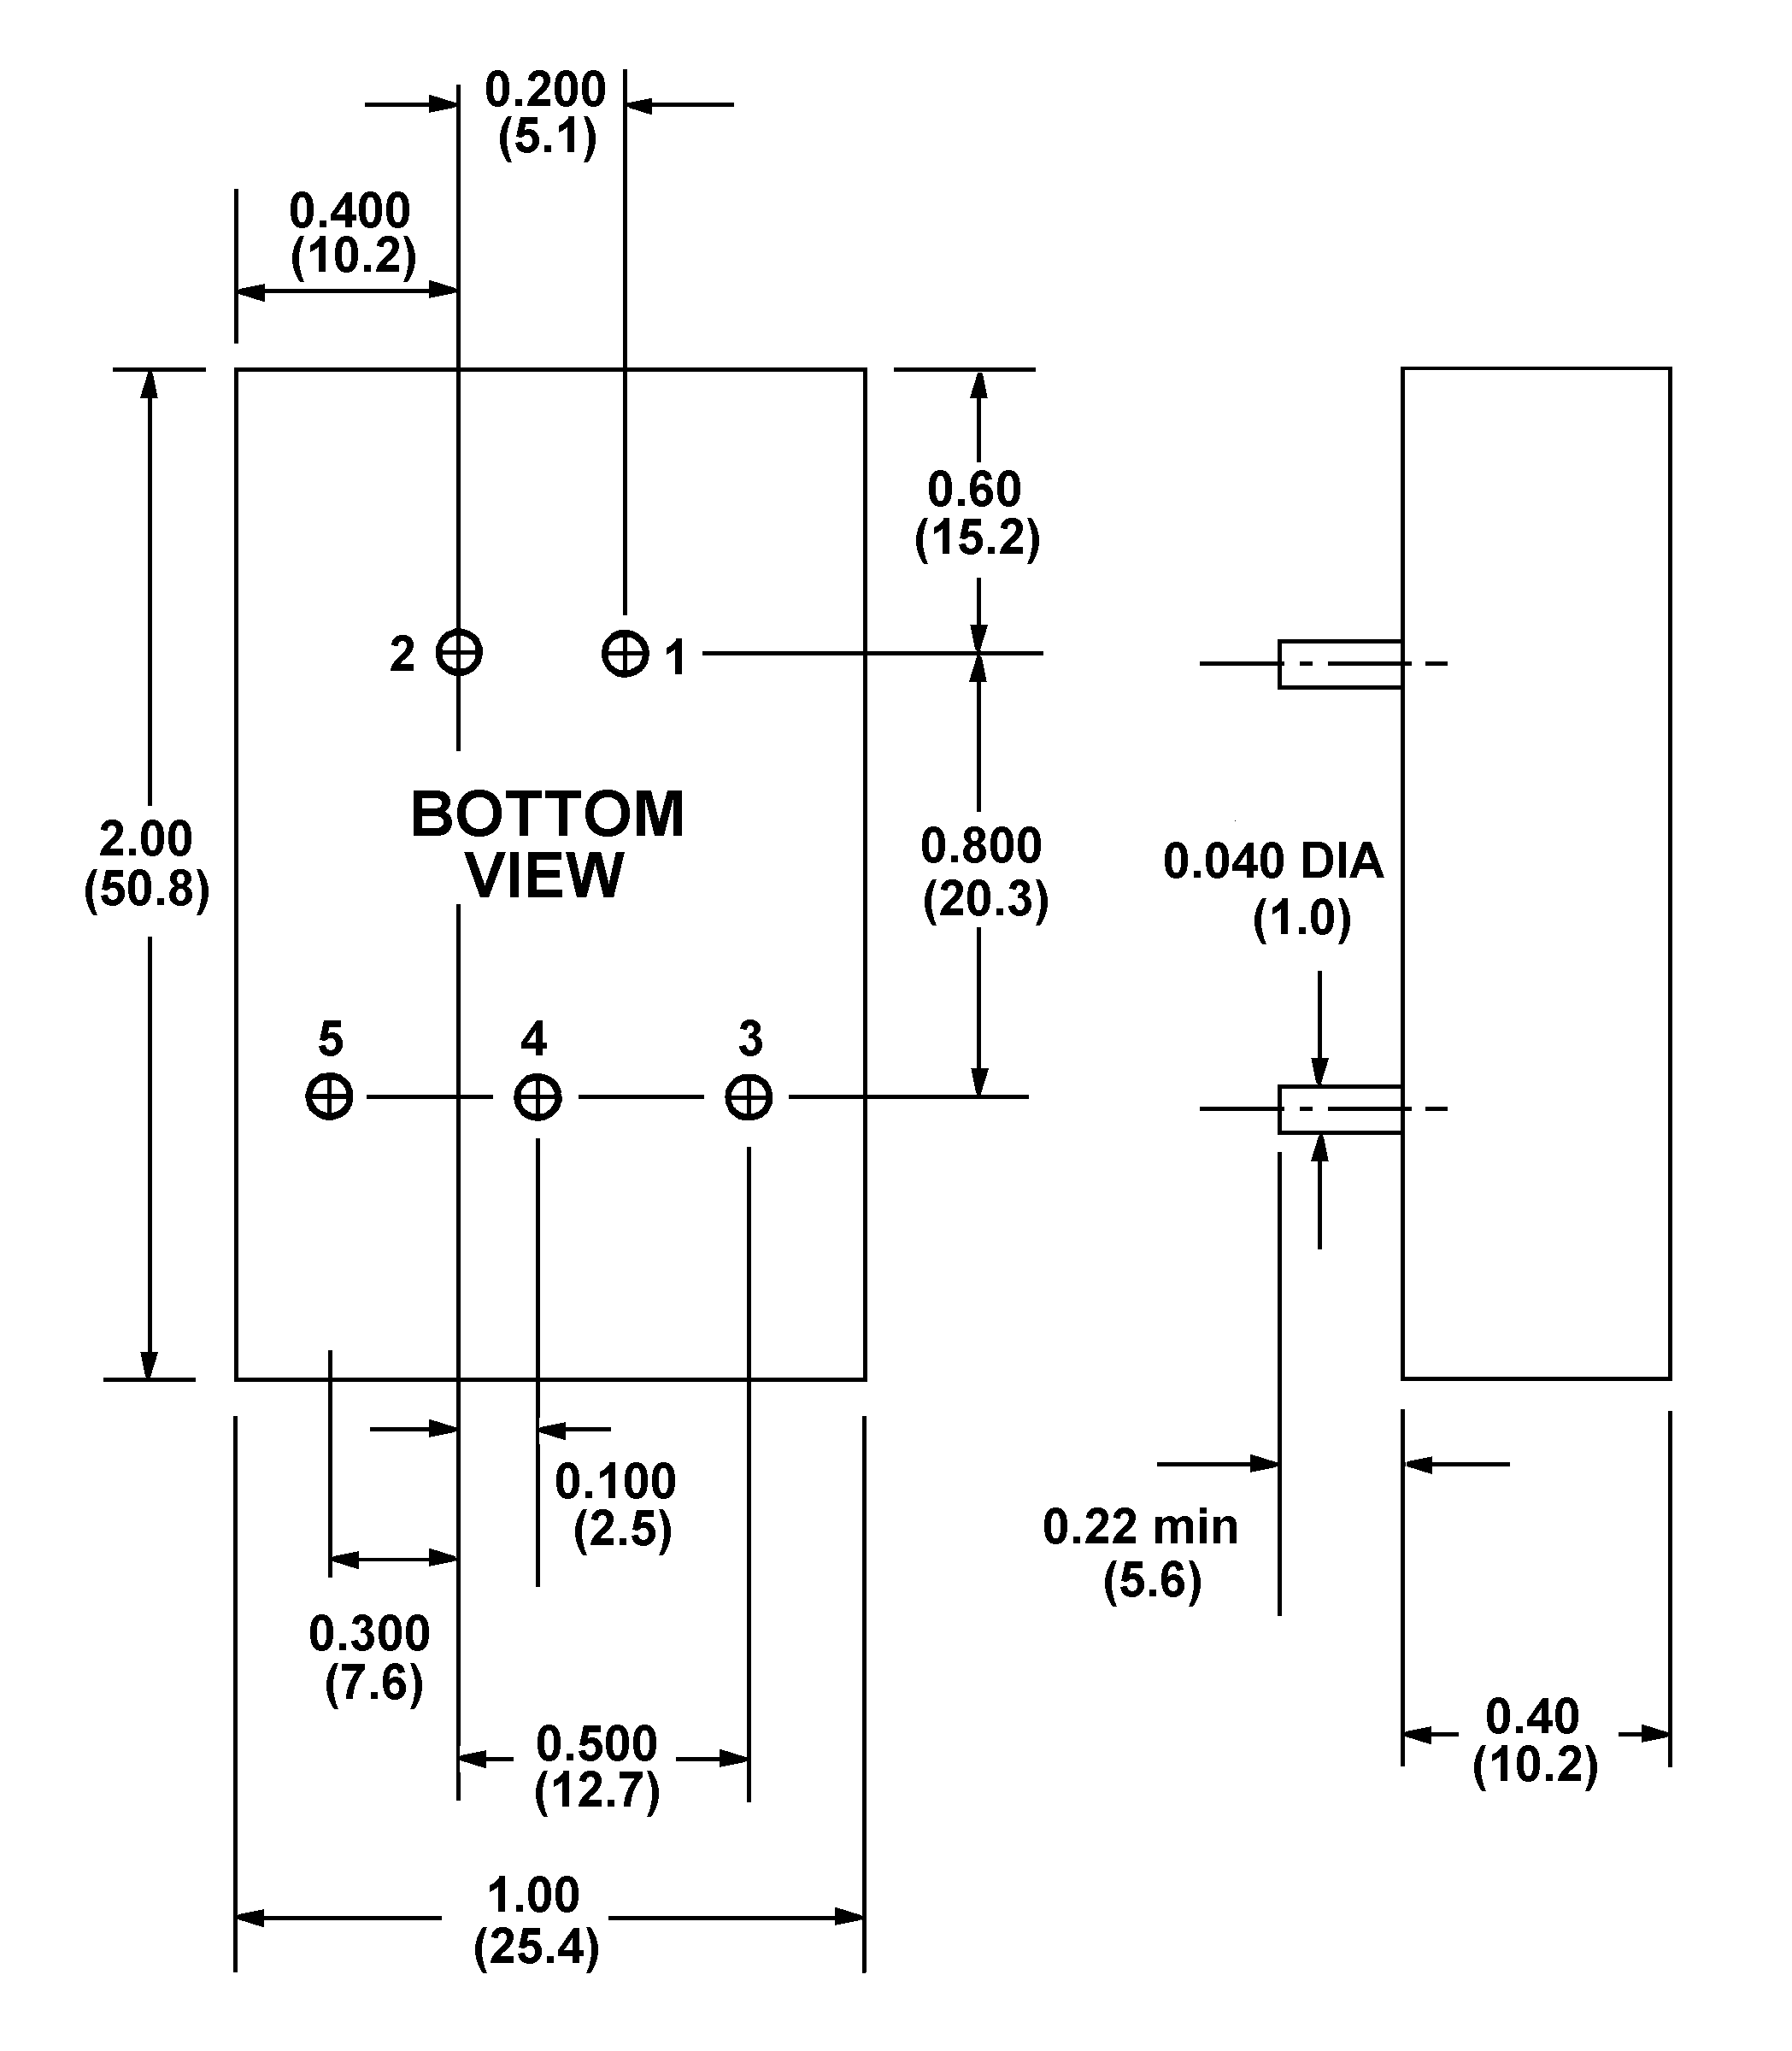
 |  |  |  |  |  |  | PIN# | SINGLE |  |  | DUAL
 |  |  |  |  |  |  | 1 | +VIN |  |  | +VIN
 |  |  |  |  |  |  | 2 | -VIN |  |  | -VIN
 |  |  |  |  |  |  | 3 | +VOUT |  |  | +VOUT
 |  |  |  |  |  |  | 4 | No Pin |  |  | Common
 |  |  |  |  |  |  | 5 | -VOUT |  |  | -VOUT
Dimensions:inches/mm
Unless otherwise specified, all tolerances are ±.005/±0.13

